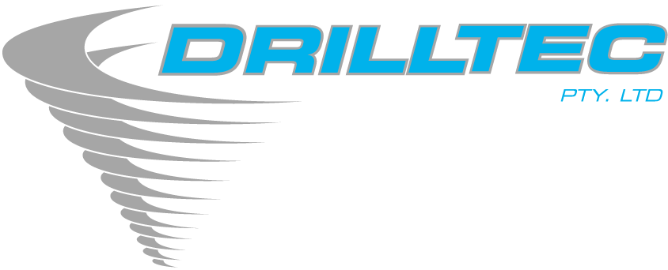

BUSINESS

POLICY

MAR 2020

DRILLTEC PTY LTD BUSINESS POLICY

It is the aim of Drilltec Pty Ltd to deliver comprehensive drilling services that meet or exceed customer expectations.

We achieve this by:

- Providing drilling services that meet or exceed the standards prescribed in AS/NZS ISO 9001:2015 and AS/NZS ISO 45001:2018 and other relevant agreements, contracts, codes or statutory obligations.

- Ensuring good internal and external communication

- Setting objectives and policies to eliminate hazards and reduce risks

- The consultation and participation of management, supervisors and all other employees

- Providing employees with training and information so that they can achieve a quality result, and work safely to reduce OH&S risks and eliminate hazards

- Continually seeking new market opportunities, embracing new ideas and technologies

- Maintaining health, safety and environmental standards that are consistent with industry codes of practice and statutory requirements

- Growing from our past experiences

- Identifying, monitoring and responding to customer requirements in a timely manner, in order to meet and satisfy their needs

- Periodically reviewing the Business Policy in order to maintain its relevance, and to improve its effectiveness.
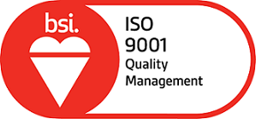
Signed: 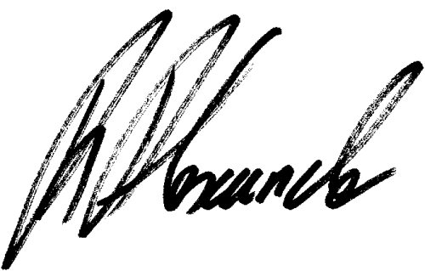
Managing Director

Dated: 20/03/2020 #Cert: FS 605180

