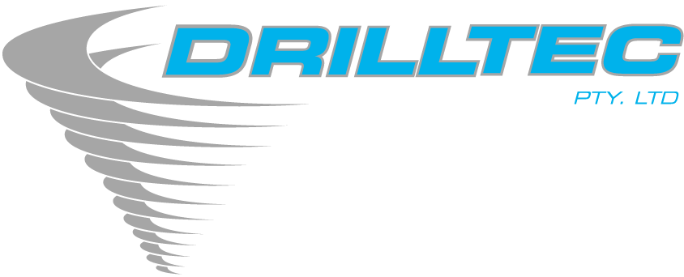

Drilltec Pty Ltd SAFETY POLICY

The Company recognises there is a risk of personnel being injured or exposed to avoidable health risk in all facets of the work that Drilltec Pty Ltd performs.

In order to reduce these risks to a practicable minimum, it is Drilltec Pty Ltd’s policy to make OH&S an integral part of project and business planning. We plan to avoid accidents affecting persons and equipment, and in so doing, avoid adverse health effects to employees and the public.

Top management is ultimately accountable for the occupational health and safety of employees, contractors, Drilltec visitors and members of the public working under its direction. It is committed to complying with the OH&S Act 2004, OH&S Regulations 2017, AS/NZS ISO 45001:2018 and any other compliance codes or guidance material.

The Company will provide a commitment to eliminate hazards, and reduce OH&S hazards, so as work can be performed in a healthy and safe manner. Appropriate systems, organisation and training will be provided so that all employees are able to contribute to work and workplace improvement. Management will ensure plant and equipment is kept in a safe condition.

The Manager and Drillers shall ensure that there are mechanisms in place to identify and prioritise safety hazards and risks in the workplace under their control, and through consultation with employees, develop plans to control these and ensure that all statutory and legal requirements are met.

The Company requires all employees to carry out work in a way that avoids injury to themselves and others. Management regards continual improvement in occupational health and safety as an essential step in improving the Company’s business performance. All workers are responsible for ensuring their own personal safety and must comply with any reasonable direction given by management for health and safety.

Personal health and safety must not be compromised in the mistaken belief that other requirements are more important.

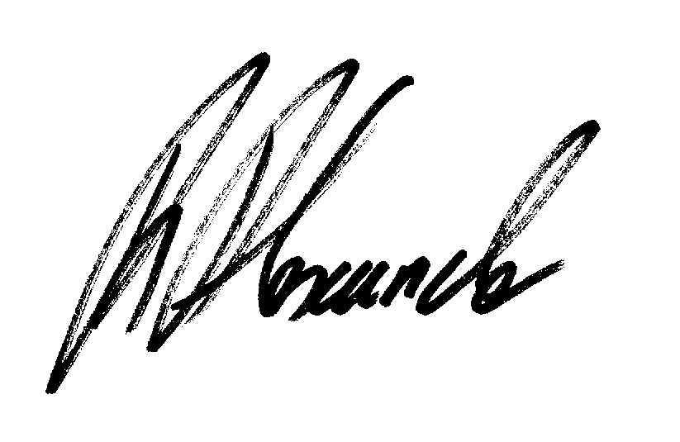
Ross Alexander

Managing Director

